Experiment 4: Scrum Project and Sprint Board in Jira
Course code: CSA1006
Course: Software Engineering
Name: B. Pavani
Register No: 192525248
Tool Used: Jira

Aim
To create a Scrum project in Jira, add tasks to the backlog, plan and start a sprint, and track the tasks on the Scrum board by moving them across the columns To Do, In Progress and Done.

Software Used
Jira Software, https://www.atlassian.com/software/jira

Procedure

Step 1: Log in to Jira
Open https://www.atlassian.com/software/jira in a browser and log in with your Atlassian account.

Step 2: Create a Scrum project
Click "Create" and choose "Space" (project), select the Scrum template and click "Use template". Enter the project name "Exp-4:Scrum project" and the key "SCRUM4", then click "Create".

Step 3: Add tasks to the backlog
Open the "Backlog" tab, click "+ Create" and type each task name ("What needs to be done?"), then press Enter. Add the five tasks listed in the table below. Jira numbers them SCRUM4-1 to SCRUM4-5.
Issue | Task Name | Purpose
SCRUM4-1 | Create User Registration | Build the user registration feature
SCRUM4-2 | Develop API for Login | Develop the API used for user login
SCRUM4-3 | Design Home Page | Design the home page of the application
SCRUM4-4 | Connect Database | Connect the application to the database
SCRUM4-5 | Test Login Functionality | Test that the login works correctly

Step 4: Create and start the sprint
In the Backlog, drag the five tasks into "Sprint 1" and click "Start sprint". Enter the sprint name, duration and start date, then click "Start". The tasks now appear on the Board in the To Do column.

Step 5: Track the tasks on the Scrum board
Open the "Board" tab and drag each card to the column that matches its progress. SCRUM4-1 (Create User Registration) was moved to Done and SCRUM4-2 (Develop API for Login) was moved to In Progress. SCRUM4-3, SCRUM4-4 and SCRUM4-5 remain in To Do.
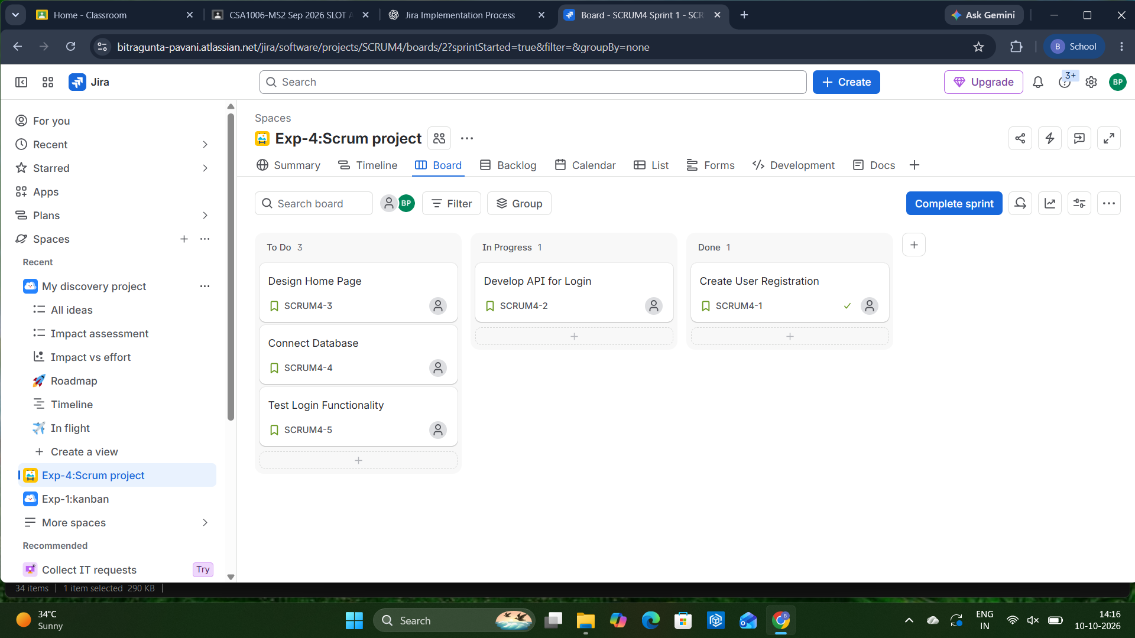
Figure 1: Scrum board of Sprint 1 in Jira after moving the tasks across the columns

Workflow Summary
Stage | To Do | In Progress | Done
Sprint started | SCRUM4-1 to SCRUM4-5 | - | -
After moving tasks | SCRUM4-3, 4, 5 | SCRUM4-2 | SCRUM4-1

Result
A Scrum project was successfully created in Jira. Five tasks were added to the backlog, planned into Sprint 1 and tracked on the Scrum board by moving them across the To Do, In Progress and Done columns.

